Calculating the Visible Curvature of the Earth from 35,000 Feet Above Ground Level
© 2017 Jay S. McMullan

From Wikipedia
However, ignoring the effect of atmospheric refraction, distance to the horizon from an observer close to the Earth's surface is about^{[5]}
However, ignoring the effect of atmospheric refraction, distance to the horizon from an observer close to the Earth's surface is about^{[5]}
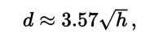
where d is in kilometres and h is height above ground level in metres.
Examples:
- For an observer standing on the ground with h = 1.70 metres (5 ft 7 in), the horizon is at a distance of 4.7 kilometres (2.9 mi).
- For an observer standing on the ground with h = 2 metres (6 ft 7 in), the horizon is at a distance of 5 kilometres (3.1 mi).
- For an observer standing on a hill or tower of 100 metres (330 ft) in height, the horizon is at a distance of 36 kilometres (22 mi).
- For an observer standing at the top of the Burj Khalifa (828 metres (2,717 ft) in height), the horizon is at a distance of 103 kilometres (64 mi).
- For an observer atop Mount Everest (8,848 metres (29,029 ft) in altitude), the horizon is at a distance of 336 kilometres (209 mi).
With d in miles (i.e. "land miles" of 5,280 feet (1,609.344 m)^{[5]}) and h in feet,
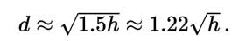
Examples, assuming no refraction:
- For an observer on the ground with eye level at h = 5 ft 7 in (1.70 m), the horizon is at a distance of 2.9 miles (4.7 km).
- For an observer standing on a hill or tower 100 feet (30 m) in height, the horizon is at a distance of 12.2 miles (19.6 km).
- For an observer on the summit of Aconcagua (22,841 feet (6,962 m) in height), the sea-level horizon to the west is at a distance of 184 miles (296 km).
- For a U-2 pilot, whilst flying at its service ceiling 70,000 feet (21,000 m), the horizon is at a distance of 324 miles (521 km)
From Wikipedia: https://en.wikipedia.org/wiki/Horizon

The information above is the distance we can see straight in front of us.

What is the distance we should be able to see straight in front of us if we are at 35,000 feet(10.668 km) above ground level (agl)? We will disregard any atmospheric haze.

Solve for d

h is our height above ground level (agl) in meters = 10668

3.57 X 103.28 = 368.73 kilometers

368.73 km = 229.12 miles is how far we can see straight ahead

Next problem:
How far from side to side (left to right) can a normal human see at 35,000 feet agl?

I have always read that with a 35mm camera, a 50mm lens approximates what the human eye sees.
The angle of view for a 50mm lens is

The normal angle of view for a human’s eyes is 46.8 degrees.

The approximate field of view of an individual human eye(measured from the fixation point, i.e., the point at which one's gaze is directed) varies by facial anatomy, but is typically 30° superior (up, limited by the brow), 45° nasal (limited by the nose), 70° inferior (down), and 100° temporal (towards the temple). Wikipedia

What is our field of view when turning our heads from left to right?

Using Autocad (extremely powerful computer aided design software) I can determine that we should be able to see 199 miles from left to right without turning our heads one a completely clear day.

To determine curvature use the formula: miles² x 8 = inches

199² X 8 = 316,808 inches of curvature.
313,632 / 12 = 26,400.67 feet of curvature
26,136 / 5,280 = 5 miles of curvature

This is we never turn our head!

Let’s say we can easily double our field of view by turning our heads (in actuality, we can probably do much more than that but let’s assume that our vision is limited by looking out of the window of an airplane and lets says we can see a field of view of 94 degrees.

Autocad tells me we should be able to turn our heads and see 476 miles from left to right!

476² X 8 = 1,812,608 inches
1,812,608 in / 12 = 151,050.67 feet
160982.64 ft / 5,280 feet = 28.6 miles of curvature

Googling “What is the diameter of the earth” I come up with 7,917.5 miles.

Using this, I plug it all into Autocad and this will show you the curvature of the earth that you should easily be able to see from inside an airplane from 35,000 ft agl.

This may not look like much but if you continue to look to your left or right, the horizon would continue to fall off more rapidly the further you look. Also, looking straight ahead, the horizon would not rise to meet your eye level.

In all reality, our field of view when turning our heads to the limits, left and right, would be more like 127 degrees. You can see just how much curvature of a globe that there should be. When we fly, even at 35,000 feet above ground level, we do not see any curvature of the earth from side to side or straight ahead.
By looking straight out the window of your airplane while at 35,000 feet above ground level, at the edge of your peripheral vision, you will see a 1.23 mile drop off on the horizon. This, of course, is if there is no haze on the horizon which is very doubtful but we will use this scenario in our examples.

By looking out the window of the airplane, again at 35,000 agl and by turning your head slightly in each direction, left and right in a 94 degree angle of vision, you will see a 7.17 mile drop off in each direction.

And finally, by turning your head in a more reasonable and realistic manner from left to right in a 127 degree angle of vision you will see an almost 22 mile drop off from left to right! Instead, anytime you fly, the horizon is ALWAYS flat! There are occasions when you will see photographs or video where there is a very pronounced curvature to the earth but in ALL of these cases a fish eye lens was used!

In 2012, Felix Baumgartner broke the altitude record for jumping and parachuting from a balloon. As he stood in the door of his capsule, ready to jump, the curvature of the earth was extremely pronounced. The problem is, a fish eye lens was used. Also, if you notice the photographs, seconds before Baumgartner’s feet the ground in the New Mexico desert, the earth still had a pronounced curvature! This is because the Go Pro camera that was being used, used a fish eye lens. Any standard lens will always show a level horizon, no matter what the altitude the photograph is taken from!

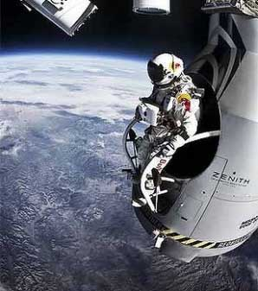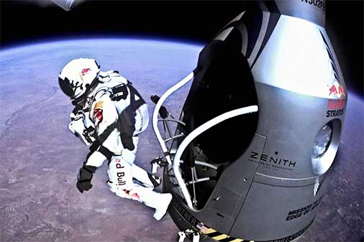
The only reason you see a curvature to earth is because of the distortion
Of a “fish eye” lens. A “normal” lens will always show a flat horizon.

